While My Guitar Gently Weeps - The Beatles

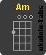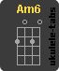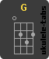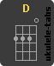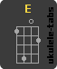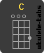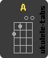

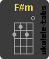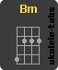

A 0 0 2 2 2 0 Am6 x 0 2 2 1 2 F#m 2 4 4 2 2 2
Amaj7 x 0 2 1 2 0 Bm x 2 4 4 3 2 Fmaj7 x x 3 2 1 0
Am x 0 2 2 1 0 C 0 3 2 0 1 0 G 3 2 0 0 0 3
Am/G 3 0 2 2 1 0 D x 0 0 2 3 2

Am Am/G Am6 Fmaj7
I look at you all see the love there that's sleeping
Am G D E
While my guitar gently weeps
Am Am/G Am6 Fmaj7
I look at the floor and I see it needs sweeping
Am G C E
Still my guitar gently weeps

A Amaj7 F#m A Bm E
I don't know why nobody told you how to unfold your love
A Amaj7 F#m A
I don't know how someone controlled you
Bm E
They bought and sold you

Am Am/G Am6 Fmaj7
I look at the world and I notice it's turning
Am G D E
While my guitar gently weeps
Am Am/G Am6 Fmaj7
With every mistake we must surely be learning
Am G C E
Still my guitar gently weeps

A Amaj7 F#m A
I don't know how you were diverted
Bm E
You were perverted too
A Amaj7 F#m A
I don't know how you were inverted
Bm E
No one alerted you

Am Am/G Am6 Fmaj7
I look at you all see the love there that's sleeping
Am G D E
While my guitar gently weeps
Am Am/G Am6 Fmaj7
Look at you all...
Am G C E
Still my guitar gently weeps

